RC CAR
TINCKER CAD SIMULATION & ARDUINO PROGRAMMING
Project overview
An RC car project involves building a wirelessly controlled vehicle, typically using a microcontroller (like Arduino) for processing commands from a transmitter (remote) to control motors, allowing for forward, reverse, and turning movements, with options for adding features like obstacle avoidance (ultrasonic sensors) or smartphone control via Bluetooth/Wi-Fi
1.Objectives
- RC car objectives range from simple fun (racing, obstacle courses) and skill-building (driving, maintenance) to educational goals (learning electronics, design, programming) and even professional applications like film or research, all while fostering creativity, technical skills, and coordination for all ages.
2.Introduction
- An RC car (Radio Controlled car) is a miniature vehicle controlled wirelessly by a handheld transmitter, popular as a hobby for fun, competition, and learning STEM skills, ranging from simple toy-grade models to complex hobby-grade ones with electric or nitro power, available as pre-built (RTR) or kits, and categorized by type (buggies, trucks, on-road) and scale. They offer thrilling precision, building, and racing experiences for all ages, teaching mechanics and engineering.
3.Block diagram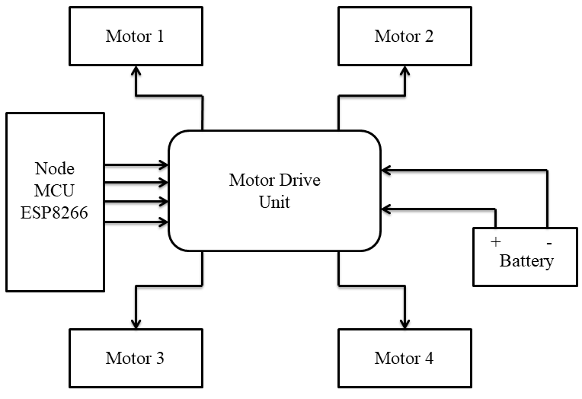
4.Components
- An RC car has core components like the Chassis (frame), Drivetrain (motor, gears to wheels), Suspension (shocks, arms for terrain), Electronics (Transmitter/Receiver, ESC, Servo for steering), Wheels/Tires, and Battery
5.wiring &pin diagram
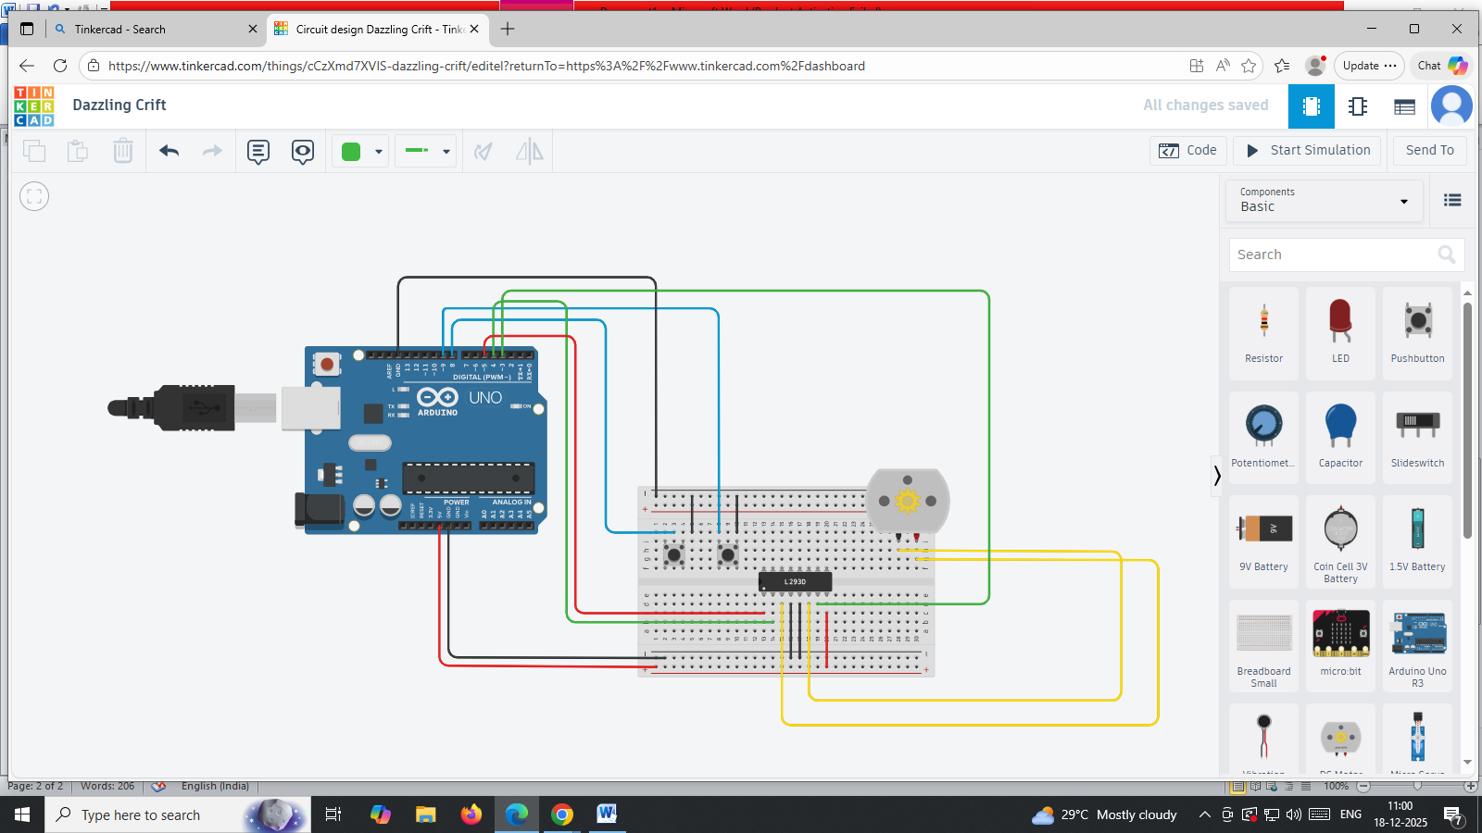
6.Building circuits in Tinkercad
- Building an RC car circuit in Tinkercad typically involves using an Arduino Uno, an H-bridge motor driver (like the L293D), DC motors, and a power source, often controlled remotely via an IR receiver. The circuit allows you to simulate the electronics and program the car's movement before building a physical model.
7.Arduino code
int MPin = 9; //motor pin
int Analog = A0; // Analog Input
int Ainp = 0; // Read analog input, initialized to zero

void setup()
{

Serial.begin(9600);
pinMode(MPin, OUTPUT);
pinMode(Analog, INPUT);
}

void loop()
{

Ainp = analogRead(A0);

int Speed = map(Ainp, 0, 1024, 0, 255);
delay(100);
Serial.println(Speed);
analogWrite(MPin, Speed);

}
8.code explanation
- RC car code explains how to program microcontrollers (like Arduino) to control a car's motors and sensors, translating simple commands (like 'F' for forward) into digital signals that tell motors to spin forward, backward, left, or right, often using libraries, serial communication (Bluetooth/WiFi), and conditional logic for autonomous features like obstacle avoidance.
9.testing & Debugging in Tinkercad
- In Tinkercad, you can design, build circuits for, program, and test (simulate) an RC car, but "dubbing" is not a standard feature. The term "dubbing" usually refers to adding audio in video production and is likely a misunderstanding of a feature in Tinkercad's testing environment.
10.what-if Testing & Behavior Analysis
- "What-if" testing and behavior analysis in the context of RC cars are primarily used in the research and development of autonomous vehicle (AV) technology. RC cars serve as scalable, cost-effective platforms for simulating real-world scenarios and testing control algorithms safely before deployment in full-size vehicles.
11.Observations
- An RC car in "observations" usually refers to watching its performance for fun (stunts, racing) or for technical study, involving monitoring speed, control, battery life, or how it handles different terrains, often linked to skill-building (coordination) or market trends, with examples ranging from simple toys to complex autonomous vehicles. Researchers might observe its interaction with algorithms (lane detection) or performance under different control systems (PID, MPC) for autonomous driving projects.
- https://www.tinkercad.com/things/cCzXmd7XVIS-dazzling-crift?sharecode=nYREnJKsKlYsPDvtyat8JqeC-AZWVf94UkK7xsSG1Dc

